

… USER’S INSTRUCTION MANUAL

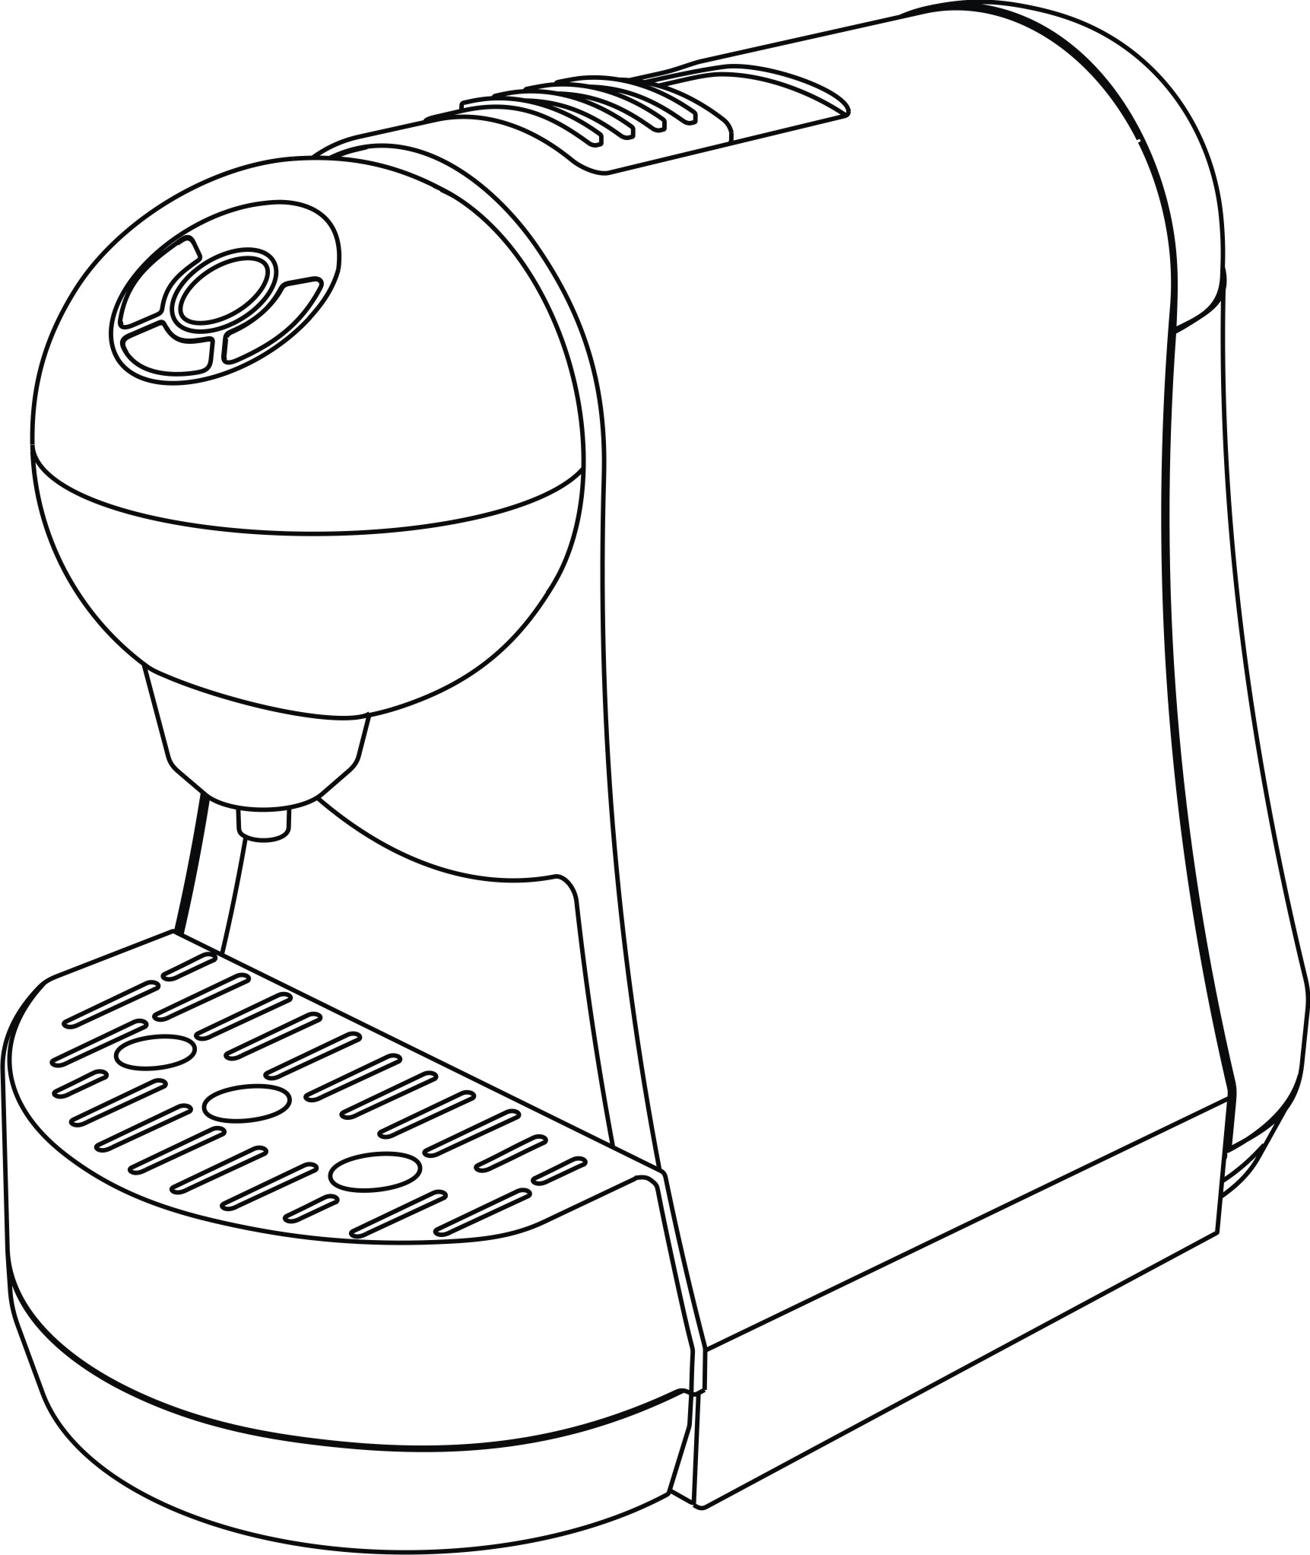

Capsule Espresso Machine
Hot Beverage Brewer

Model RC-1802


READ INSTRUCTION CAREFULLY: Read and follow all instructions. Place instructions in a safe place for future reference. Do not allowanyone who has not read these instructions to assemble, light, adjust or operate the appliance.

IMPORTANT INSTRUCTIONS………………………………. …
PLEASE READ AND SAVE THESE IMPORTANT SAFETY INSTRUCTIONS
When using electrical appliances, basic precautions should always be followed to reduce the risk of the fire, electric shock, and injury to persons, including the following：
1. Read all instructions before using.
2. In case of emergency, immediately remove the plug from power outlet.
3. Check the voltage indicated on the rating label on the appliance does in fact match that of your electrical system.
4. This appliance is not intended to for use by persons(including children) with reduced physical, sensory or mental capabilities, or lack of experience, and knowledge, unless they have been given
supervision or instruction concerning use of the appliance by a person responsible for their safety. Children should be supervised to ensure that they do not play with the appliance
5. Do not operate the appliance with a damaged cord or plug or after the appliance malfunctions, has been dropped or damaged in any manner. Return the appliance to authorized service facility for examination, electrical or mechanical adjustment, or repair.
6. Always unplug the appliance when not in use or before cleaning. Allow to cool before adding or removing parts, and before cleaning the appliance.
7. To protect against fire, electric shock and personal injury, do not immerse cord, plug or appliance in water or other liquid. Never clean the appliance or the power cord if those are humid. Avoid touching the appliance with wet hands.
8. Do not run cord under carpeting. Do not cover cord with throw rugs, runners or similar coverings. Arrange cord away from traffic area and where it will not be tripped over.
9. Avoid the use of an extension cord because the extension cord may over heat and cause a risk of fire. However, if you have to use an extension cord, the cord shall be rated not less than 2,000 watts. Only use an earthed socket to connect the appliance.
10. Do not place on or near a hot gas or electric burner, or in a heated oven.
11. It is normal for the plug to feel warm to the touch; however, a loose fit between the AC outlet(receptacle) and plug may cause over heating and distortion of the plug. Contact a qualified
electrician to replace loose or worn outlet.
12. Use the appliance only as the described in this manual. Any other use or accessory attachments not recommend by the manufacture may cause fire, electric shock, or injury to persons.
13. Do not put fingers inside capsule housing(brewing chamber), due to sharp edges.
14. Do not touch hot surfaces. Use levers.
15. Indoor & domestic use only.
16. Hot water, spout and capsule holder are hot. Danger of burning injuries. Do not put hot water towards the body.
17. Do not operate the appliance when the drip tray and the grille are not in place.
18. Use only water in the appliance! Do not put any other liquids or foods in the Water Reservoir.
19. If the supply cord is damaged, it must be replaced by the manufacture, it’s service agent or similarly qualified persons in order to avoid a hazard.
20. WARING: The filling aperture must not be opened during use.
21. This appliance is intended to be used in household and similar application such as:
- Indoor & domestic use only.;
- farm houses;
- by clients in hotels, motels and other residential type environments;
- bed and breakfast type environments.
- staff kitchen areas in shops, offices and other working environments;

PRODUCT INSTRUCTION
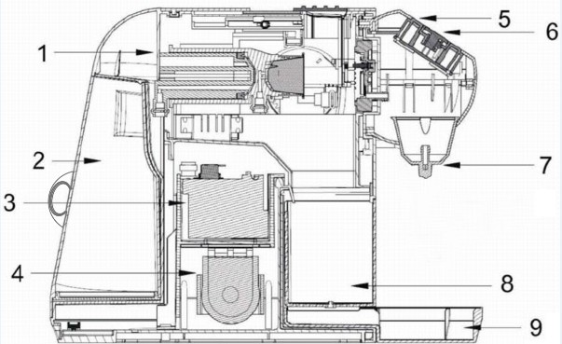

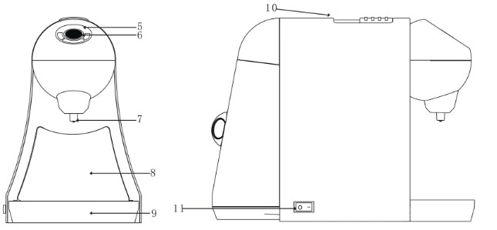

8. Waste capsule collection container 1. Brewing Chamber 9. Removable drip tray with detachable
(Capsule Squeezer for extraction) grille
2. Water tank(reservoir) 10. Brewing chamber cover
3. Thermal block(boiler) 11. On/Off switch
4. Solenoid pump
5. Pre-heating indicator & Power indicator
6. Front control button （short & lungo & manual）
7. Coffee/beverage outlet, hot water outlet Can be screwed off for cleaning）

OPERATING INSTRUCTIONS………… …………
- Start up
Fill the water tank with fresh clean water, pure water is strongly recommended to avoid scale in the machine, and the water level should no lower than the Min. position and no higher than the Max. Position. Switch on the machine at the On/Off switch, the machine will then be preheated. Check the below procedure of coffee/ espresso brewing or inside system cleaning before first use.

- Coffee/Espresso brewing
Firstly, switch on the machine at the On/Off switch, it starts preheating. When the blue indicator is blinking shows the machine is preheating; when the machine is ready, blue indicator stops blinking.
Insert the capsule into the capsule holder according to the shape and direction by moving the slidable cover to open and close.
Press the front control button to get coffee with a desired volume and the capsule will drop into the waste capsule collection container automatically in several seconds:
Short cup: when the volume of coffee reaches to about 30ml, the machine will stop automatically.
Lungo cup: when the volume of coffee reaches to about 60ml, the machine will stop automatically.
Manual control: press once to make the coffee, press another time when the volume reaches to the desired.

3. To get hot water
Just repeat the coffee brewing procedure without inserting a capsule, you will get hot water.
4. Notes
1. Do not move the water tank away from the machine when the hydraulic system is still moving.
2. The volume of the waste capsule collection container is limited, please move the waste capsule away from the container after 12 times using maximum.
3. Use only water in the appliance! Do not put any other liquids or foods in the Water tank.

TROUBLE SHOOTING…………………………………….… ……
Problem | Solution
On/Off Switch not on | Check plug, main switch and fuses
No coffee dispensed | Make sure the capsule properly positioned, capsule slot not obstructed, brewing chamber cover properly closed, water tank full and properly placed.
Coffee not hot enough | Preheat cup(hot water without capsule), descale if necessary.
Noisy pump | Repeat the priming procedure. Make sure the water tank is full and properly placed.
Capsule area leaking  (water in capsule container) | Position capsule correctly.  If leakage: contact the distributor or service

CLEANING AND MAINTENANCE……… …….….
1. System Cleaning
To refresh the inside parts of the system, you can choose to repeat the procedure of coffee brewing several times and meantime try to brush the inside brewing chamber capsule holder with a soft brush between different times. Clean the casing, with a soft damp cloth. The water tank, drip try and used capsule collection container can be washed in warm water.

Note:
Before attempting to clean the appliance, remove the plug from the power outlet. Do not immerse the machine, and/or power cable in water or other liquids. Allow the machine to cool before starting the cleaning procedure.

2. Descaling
Choose the recommended decalcifier or scale remover from your machine provider and repeat the same procedure as coffee brewing without inserting any capsule.

SPECIFICATION……………………………………………………
Rated Voltage: AC100~120V
Rated Frequency: 60Hz
Rated Power: 1,400W (Rated Boiler power: 1350W)
N.W./G.W.: 3.5/4.0 kgs
Pump Power: 55W
Pump Pressure: 15-20 Bars
Water Tank Capacity: 1.0L
Drip Tray Capacity: 350ml
Protection Class: I
Product size: 35L x 18W x 27H cm

USER’S INSTRUCTION MAN

Product Size: 34L * 18W * 27H cm

LIMITED WARRANTY & SERVICE………………………………

